

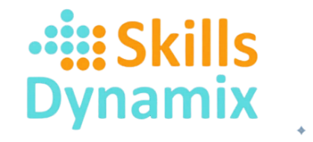
Submitted By
- Mohamed Ahmed Abdelsalam - Nadine Abdel Razak
- Abdel Rahman Mohamed - Mariam Abdelaleem
- Aly Gweida - Abdel Rahman Ahmed

Smarter data, better Education

Education System Monitoring

May 2026 | May 2026 | Data Engineering & AI track | [Course title]

Table of Contents

Project Planning & Management 3
Project Proposal 3
Project Idea 3
Problem statement 3
Tools and technologies 4
Targeted audiences 4
Project Plan & Timeline 5
Task Assignment and Roles 5
Executive Summary 8
1- Project Scope & Scale 8
2- Technology Stack 9
3. System Architecture Overview 9
4. Tools used 10
5.1 Technical Metrics & Pipeline Specifications 11
5.2 Bronze Layer — Raw Data Ingestion 11
6. Design Justification: Why We Chose These Technologies 14
6.1 Data Engineering Decisions 14
6.2 Business Intelligence Decisions 15
Power BI and Dashboard 16
3- Different relations showed in our dashboard 20
4- Our dashboard 23
4.1 Home page 23
4.1 Academics & Demographics 24
Data Modeling & Relationships 25
4.3 Socio-Economic overview 26
4.4 Wellbeing & Habits 27
Data Modeling & Relationships 28
4.5 LMS Engagement 28
Data Modeling & Relationships 29
4.6 Attendance & Compliance 30
Data Modeling & Relationships 31
4.7Subject Correlations 31
Data Modeling & Relationships 32
Data Modeling & Relationships 34
4.8Education Path 34
Data Modeling & Relationships 35
4.9 Factors affecting performance 36
Data Modeling & Relationships 37
4.10 Improvement of Education and Technology 37

Data Modeling & Relationships 38
AI-Powered Educational Chatbot 40
1 System Architecture 40
Tools 40
2 RAG Pipeline 41
3 Hybrid Routing Logic 41
6.AI Chatbot Decisions 45
Conclusion 47
Final Positioning Statement 47

Project Planning & Management

Project Proposal

Project Idea
This project proposes the design and implementation of an AI-driven educational support system tailored for schools, aimed at enhancing students’ academic performance,
improving the learning process, and assisting students in identifying the most suitable academic field for higher education.
The system will leverage student academic, behavioral, and attendance data, alongside
teacher performance and feedback data, to provide intelligent insights through a customized chatbot interface. This chatbot will act as an interactive assistant for students,
teachers, and school administrators by offering academic guidance, performance analysis,
and data-driven recommendations.
By integrating artificial intelligence, data analytics, and educational data mining, the proposed system seeks to support personalized learning, early academic intervention, and
evidence-based educational decision-making within schools.

Problem statement
Many schools face persistent challenges in monitoring students’ academic progress, identifying learning difficulties early, and guiding students toward suitable college majors. Traditional educational systems often rely on fragmented data sources, manual evaluation, and generalized teaching approaches, which may fail to address individual student needs.
Additionally, students frequently lack structured guidance to help them understand them
strengths, learning styles, and long-term academic pathways. Teachers and school administrators, on the other hand, may not have access to advanced analytical tools that help evaluate classroom effectiveness or improve teaching strategies based on student outcomes.
The absence of an integrated, intelligent system leads to:
- Delayed identification of academic or behavioral issues
- Limited personalization of the learning experience
- Inefficient use of educational data
- Insufficient data-driven feedback for teachers and decision-makers
This project addresses these challenges by providing an AI-powered system that transforms raw educational data into meaningful insights and actionable guidance.

Tools and technologies
The project will utilize a combination of modern data, AI, and cloud technologies:
3.1. Programming and Data Processing
- Python: Core language for data analysis, machine learning, and AI model development
- SQL: Storage, querying, and management of relational educational data
3.2. Data Analytics and Visualization
- Power BI: Interactive dashboards for academic performance, attendance trends, and teacher evaluation
3.3. Artificial intelligence and machine learning
- Machine learning libraries
- Natural Language Processing (NLP) frameworks for chatbot development
- n8n AI Agent: It will manage data workflows between databases, AI models, dashboards, and the chatbot interface.
3.4. Cloud and infrastructure
- Cloud platforms (e.g., AWS, Microsoft Azure, Google colab) for scalable data storage and deployment

Targeted audiences
The primary targeted audience of the project includes:
- Schools (administrators and management)
- Students at the secondary education level
- Teachers and academic staff
The system is designed to be adaptable to different school environments while maintaining a user-friendly interface suitable for non-technical users.
Expected output
The expected outcomes of the project include:
- A fully functional AI-powered chatbot system for schools
- Intelligent dashboards summarizing student and teacher performance
- Personalized learning and career recommendations for students
- Data-driven feedback and evaluation reports for teachers
- Improved academic monitoring and early intervention capabilities
- Enhanced overall learning experience within the school environment

Project Plan & Timeline
Duration: 9 weeks
Phase | Timeline | Deliverables | Tool
Phase 1:  Project Planning & Setup | Week 1 | Project plan and proposal | PPT, planning tools
Phase 2:  Data Ingestion | Week2-3 | Data set from Kaggle or Educational institution | Data set from Kaggle or csv
Phase 3:  Stream Processing | Week 3-4 | Processes data in delta | Py spark
Phase 4:  Data Storage & Lake | Week 5 | Data lake setup | one lake (Lakehouse)on fabric
Phase 5:  Batch ETL & Data Warehouse | Week 6-7 | ELT pipeline and SQL DWH | Py spark  SQL
Phase 6:  Visualization Layer | Week 8 | Dashboard | Power BI
Phase 7: AI Modeling &  Deployment | Week 8-9 | LL m model and rag system and API | Python, Flask

Task Assignment and Roles
Team member | Role | Key Responsibilities
Mohamed El Kordy | Data analysis | Power Bi dashboard
Abdel Rahman Mohamed | Data Engineer | Visualization relation to be study
Mariam Abdelaleem | AI engineer | AI chat bot model
Aly Gweida | Data Analyst | Cleaning, formatting data set, documentation
Abdel Rahman Ahmed | Data Engineer | ETL & Data Warehouse design  (Py Spark + MySQL)
Nadine Abdel Razak | Data analysis | Dashboard development  support, data analysis, final ppt and documentation

Key Performance Indicators (KPIs) Student_ID
- How do academic and demographic factors (department, gender, age, and subject difficulty) influence student performance?
- How do socio-economic factors such as family income, parent education, and internet access affect academic achievement and LMS engagement?
- How do student wellbeing and study habits including study hours, sleep quality, stress levels, and extracurricular activities impact academic success?
- How does LMS engagement (login frequency, active hours, and resource access) contribute to student performance and learning outcomes?
- How do attendance and behavioral patterns such as academic attendance, late assignments, and procrastination affect student achievement?
- What correlations exist between subjects and assessments such as Math, Science, Computer Science, assignments, and final scores?



Executive Summary
The Data-Driven Education Monitor is a comprehensive, end-to-end data analytics platform designed to transform raw student data into actionable intelligence for educators and administrators. Built on the Microsoft Fabric ecosystem and powered by Apache Spark, the system ingests, cleans, and models records for 1,356 students across three school departments, surfacing insights across nine interconnected Power BI dashboard pages.

Beyond traditional reporting, the project integrates an AI-powered chatbot combining Retrieval-Augmented Generation (RAG) with a Pandas analytical agent, enabling natural language interrogation of the educational dataset. Together, the BI dashboards and chatbot provide a 360-degree view of student performance — encompassing academic scores, socio-economic background, wellbeing, digital engagement, and behavioral compliance.

1.Project Scope & Scale
Dataset:
- 1,356 student records ·
- 34 raw features ·
- 3 school departments
Pipeline:
- 3-tier Medallion Architecture (Bronze → Silver → Gold) ·
- 5 analytical Data Mart views
Dashboards:
- 9 Power BI pages ·
- 35+ distinct visualizations
AI Chatbot:
- Hybrid RAG + Pandas Agent · Flask backend · HTML/JS frontend
Project positioning:
An industry-style prototype demonstrating enterprise data engineering, business intelligence, and applied AI on a unified modern data platform.

1.Data Rectificatoin Resultss
Six behavioral and socio-economic attributes were simulated using domain-driven logical constraints, not random values:
- Internet Access: Derived from Family_Income_Level via probability logic — High income (~95%), Medium (~75%), Low (~35%).
- Academic Attendance: Modeled from Total_Avg with tiered attendance bands (e.g., Avg ≥ 85 → 90–100% attendance).
- Study Hours: Assigned from Grade category (e.g., Grade A → 26–35 hrs/week, Grade F → 1–5 hrs/week).
- LMS Engagement: lms_login_freq_per_day and resource_access_avg_hrs scaled by academic performance and internet availability.
- Sleep Hours: Modeled per grade to reflect academic pressure patterns observed in educational research.
Stress Level: Calculated by custom formula: Stress = 10 − ((Sleep − 4) / 5) × 8 + Noise. Late assignments directly linked to resulting stress score.

Technology Stack
Component | Technology
Cloud Platform | Microsoft Fabric
Processing Engine | Apache Spark (PySpark)
Storage Format | Delta Lake · ACID transactions · Time-travel versioning
Query Language | Spark SQL + Python
BI & Visualization | Microsoft Power BI
NLP Framework | LangChain
Embedding Model | Hugging Face sentence-transformers
Vector Store | FAISS / ChromaDB
Backend API | Flask (Python)
Frontend | HTML + CSS + JavaScript

3. System Architecture Overview
The diagram below illustrates the complete end-to-end data flow of the platform, from raw CSV ingestion through the three Medallion layers on Microsoft Fabric, into Power BI dashboards and the AI chatbot, and finally to end-user stakeholders.
Metric | Detail | Value
Dataset size | Student records ingested from CSV | 2448 rows
Feature count | Raw columns before standardization | 34 columns
Schema renames | Columns renamed in Bronze layer | 34 mappings
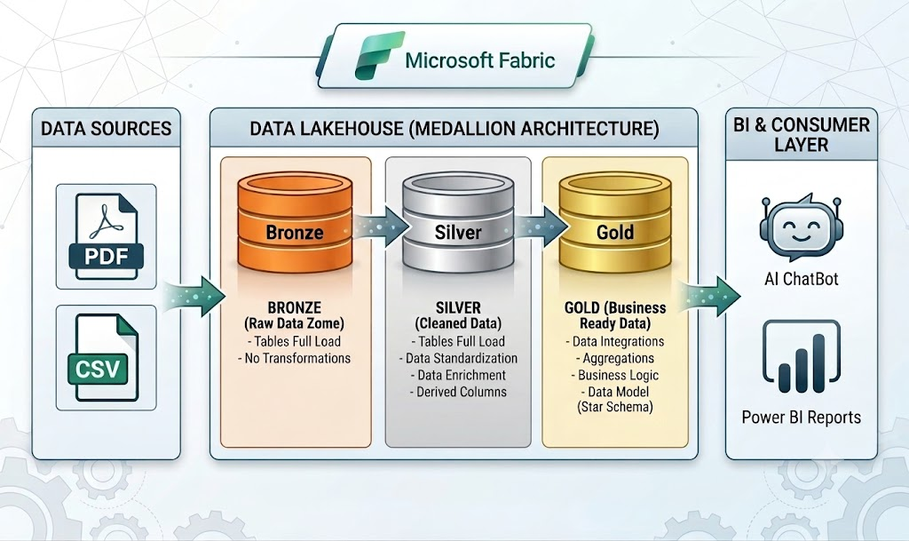
End-to-End Data Architecture — Full Platform Flow
▼ RAW DATA SOURCE
data_depi_final.csv · 1,356 student records · 34 raw columns · 3 school departments
▼ MICROSOFT FABRIC · Apache Spark (PySpark) · Delta Lake Storage
▶ BRONZE  Raw ingestion  Schema standardization  Delta: bronze. Students | ▶ SILVER  Cleaning & deduplication  Feature engineering  Behavioral simulations | ▶ GOLD  Star Schema design  Fact + 4 Dim tables  5 Data Mart views

ACID transactions · Time-travel versioning · Schema enforcement · Spark SQL analytics
▶ POWER BI · 9 Dashboards  Demographics, Socio-Economic, Wellbeing  LMS Engagement, Attendance, Correlations  Education Path, Factors, Improvement | ▶ AI CHATBOT · Flask + LangChain  Pandas Agent for analytical queries  RAG pipeline for contextual questions  Hybrid router · HuggingFace embeddings

▼ STAKEHOLDERS · Educators · Counselors · Administrators

4. Tools used
Tool | Definition
Microsoft Fabric | Cloud-based platform that unifies data warehousing, analytics, and AI into a single, seamless SaaS environment, eliminating the need to connect separate services.
Py Spark | A powerful, distributed engine that processes massive datasets at lightning speed by splitting tasks across multiple servers, using PySpark as its Python interface.
Delta Lake | An open-source storage layer for data lakes that ensures reliability and speed by offering ACID transactions to prevent data  corruption and Time-travel versioning to query historical data states
SQL | A specialized Apache Spark module that allows data engineers to run structured relational queries on big data, combining familiar SQL syntax with Python programming in a single pipeline.

5. Data Pipeline: Medallion Architecture on Microsoft Fabric
The ETL pipeline follows the Medallion Architecture, organizing data into three progressive quality tiers. All tables are persisted as Delta Lake tables to guarantee ACID transactions, time-travel, and schema enforcement.

5.1 Technical Metrics & Pipeline Specifications
Metric | Detail | Value
Dataset size | Student records ingested from CSV | 1,356 rows
Feature count | Raw columns before standardisation | 34 columns
Schema renames | Columns renamed in Bronze layer | 34 mappings
Delta tables | Total Delta tables created | Bronze(1) + Silver(1) + Gold(6)
Data Mart views | Specialised analytical Delta views | 5 views
Engineered features | Simulated behavioral attributes | 6 features
Star Schema tables | Fact + Dimension tables in Gold | 1 Fact + 4 Dim
BI Dashboard pages | Power BI report pages | 9 pages
Total visualizations | Distinct charts and AI visuals | 35+

5.2 Bronze Layer — Raw Data Ingestion
The Bronze layer performs faithful ingestion with minimal transformation, establishing a permanent audit trail of source data.
- Source: CSV file (data_depi_final.csv) loaded into a Spark DataFrame via PySpark.
- Schema Standardization: A mapping dictionary renamed all 34 raw columns into clean, consistent names (e.g., First_Name, Student_ID, Math_Score, Family_Income_Level).
- Storage: DataFrame written as Delta Table (bronze. students) enabling full ACID compliance and row-level versioning from the first layer.
5.3 Silver Layer — Data Cleaning & Behavioral Simulation
A. Data Quality Operations
- Deduplication: dropDuplicates() removed any redundant records before enrichment.
- Null Audit: Comprehensive null-value analysis performed across all 34 features to ensure integrity prior to feature engineering.
- Formatting: All numeric metrics rounded to two decimal places for reporting consistency.
5.4 Gold Layer — Star Schema & Analytical Data Marts
The Gold layer organizes cleaned data into a Star Schema optimized for Power BI Direct Query performance.
Table / View | Description
Fact_Performance | All quantitative measures: subject scores, attendance, stress, LMS hours, late assignments
Dim_Identity | Student demographics: Name, Age, Gender
Dim_Academic_Context | Academic status: Department, Grade, Extracurricular Activities
Dim_Social | Socio-economic background: Family Income, Parent Education Level
Dim_Assignments | Assignment submission metrics: on-time vs. late counts by student
Mart_Demographics | Analytical view: performance breakdown across gender and departments
Mart_Socioeconomic | Analytical view: family income vs. digital engagement correlation
Mart_Study_Stress | Analytical view: study hours, sleep, and stress relationship by grade
Mart_LMS | Analytical view: LMS platform activity vs. final academic scores
Mart_Attendance | Analytical view: attendance compliance vs. late submission patterns
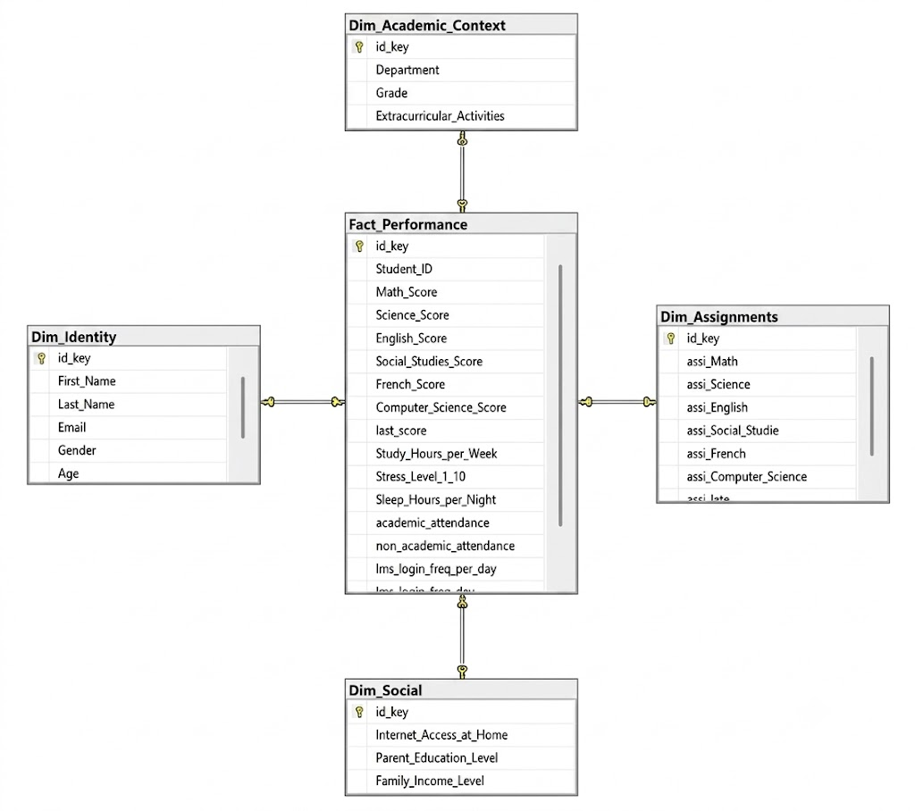
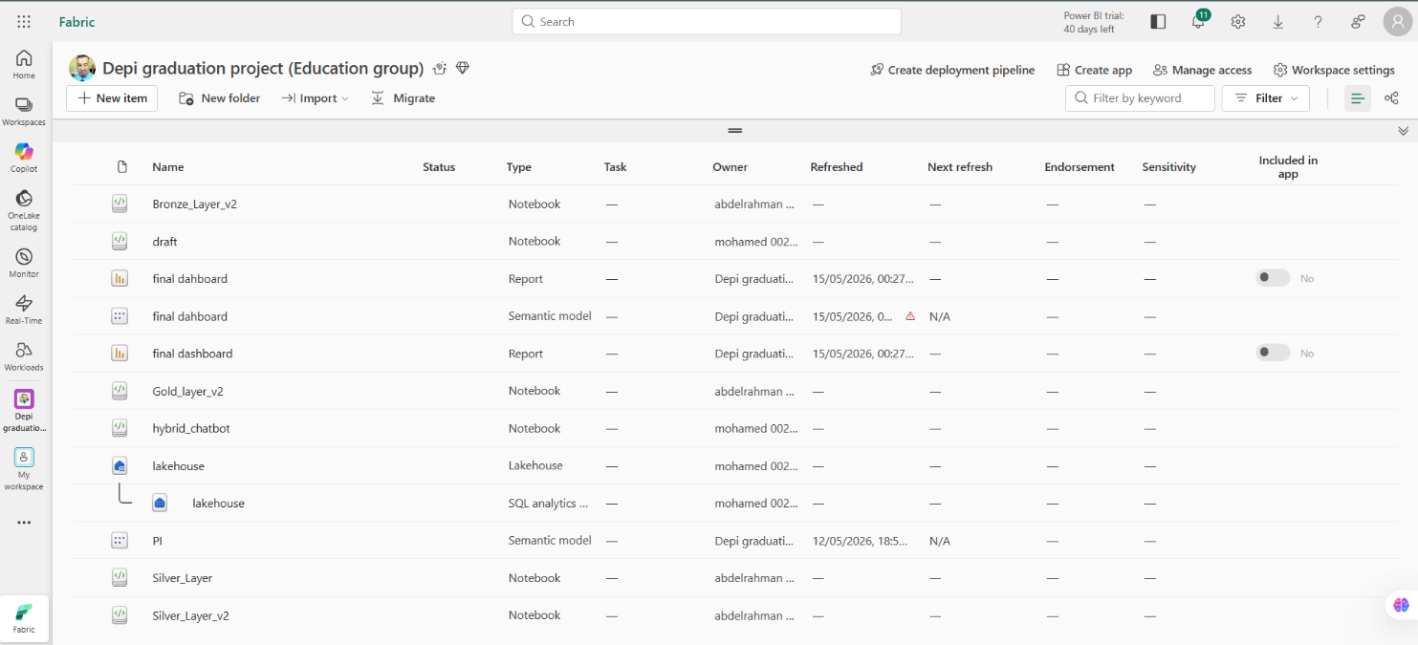

6. Design Justification: Why We Chose These Technologies
This section documents the reasoning behind key architectural decisions. Every technology was chosen deliberately based on engineering requirements, not convention. These justifications are also answers to the questions most commonly asked in project defenses.

6.1 Data Engineering Decisions
1- Q: Why did you choose the Medallion Architecture?
A: The Medallion Architecture separates concerns across three layers with clear, enforceable quality contracts. The Bronze layer preserves a raw, immutable copy of source data essential for auditability and reprocessing if business logic changes. The Silver layer enables complex transformations and behavioral simulations without corrupting raw data. The Gold layer organizes clean data into a Star Schema optimized for analytical query patterns. This progressive quality model is the standard approach in modern data lake houses and directly mirrors how enterprise platforms like Databricks and Microsoft Fabric are structured in industry.
2- Q: Why did you choose Delta Lake as the storage format?
A: Delta Lake was chosen over plain Parquet or CSV for three critical capabilities: (1) ACID transactions guarantee no partial writes corrupt the table during pipeline runs; (2) time-travel versioning allows querying any historical snapshot of the data essential for debugging and reproducibility; and (3) schema enforcement prevents upstream schema changes from silently corrupting downstream tables. For a multi-layer pipeline where each layer reads from the previous one, these guarantees are architectural necessities, not optional features.
3- Q: Why use Apache Spark (PySpark) when the dataset is only 1,356 rows?
A: Three reasons: First, scalability the pipeline is designed to scale. The same PySpark code that processes 1,356 rows processes 1.3 million rows without code changes, only infrastructure changes. Building in Pandas would require a complete rewrite at scale. Second, platform alignment Microsoft Fabric is natively a Spark-based platform; PySpark is the idiomatic and supported approach, not an overengineering choice. Third, SQL expressiveness Spark SQL enables the analytical views and Star Schema decomposition to be expressed as declarative, maintainable queries rather than imperative row-by-row Python code.

6.2 Business Intelligence Decisions
1- Q: What is the most important KPI in the project, and why?
A: The most strategically important KPI is Academic Attendance Rate by Grade. It is the single variable most strongly correlated with academic outcome across the entire dataset A-grade students maintain 95% attendance while F-grade students average only 39%. Unlike study hours or LMS logins (which are private behaviors), attendance is directly observable and actionable by administrators in real time. It serves as both a leading indicator (early attendance decline predicts grade decline) and a lagging indicator (poor grades correlate with retrospective attendance gaps).
2- Q: How would an actual school use this dashboard system?
A: Three concrete use cases:
(1) Early Warning System administrators monitor Attendance & LMS Engagement dashboards weekly; any student whose login frequency drops below 1 per day or attendance falls below 75% triggers a counselor check-in, intervening before grades deteriorate.
(2) Resource Allocation the Socio-Economic dashboard identifies students lacking home internet, enabling targeted offline resource distribution or lab access scheduling.
(3) Pathway Guidance counselors use the Education Path radar chart to identify each student’s strongest subject cluster and advise on STEM vs. Humanities tracks, backed by data rather than subjective impression.

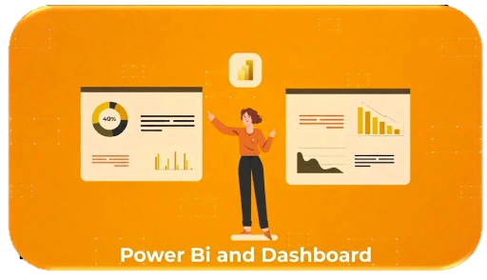
Power BI and Dashboard
The Power BI layer consists of nine interconnected dashboard pages, each serving a distinct analytical purpose and connected to the gold layer Data Mart views. Below is a detailed walkthrough of each page with its key insights.
Tool | Definition
Microsoft Power BI | A leading business intelligence tool that transforms raw data into interactive charts and live dashboards, bridging the gap between engineering pipelines and business stakeholders with actionable visual insights.

1-Power BI in Educational Analytics
The provided diagram illustrates a comprehensive educational analytics framework centered around Power BI. As the central hub, Power BI is utilized to integrate, visualize, and analyze diverse dimensions of student and institutional data, providing a 360-degree view of the educational environment. The surrounding nodes represent key analytical modules, which encompass academic progress, demographics, attendance compliance, and Learning Management System (LMS) engagement. Furthermore, the framework goes beyond basic metrics by tracking complex variables such as socio-economic overviews, student wellbeing and habits, specific education paths, subject correlations, and other underlying factors affecting performance. Ultimately, this holistic, data-driven approach is designed to guide the continuous improvement of both education and technology.
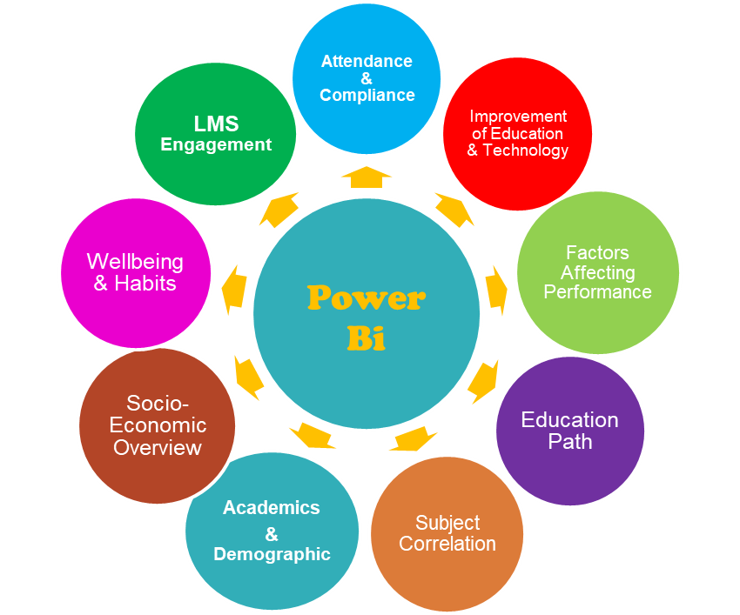

2-Different type of relation used in our dash board
Shape | Type | Usage
 | Pie Chart | It is the best visual to show "parts of a whole" when you only have two or three categories. It instantly communicates the 50/50 balance to the audience without them needing to read the actual numbers.
 | Standard Column & Bar Charts | This is the ideal tool for "direct comparison" across distinct, independent categories. It allows the audience to easily compare lengths and immediately see the highest and lowest values at a glance.
 | Clustered Column/Bar Charts | To compare "sub-groups" within a primary category. It highlights the differences and nuances inside a specific segment (like comparing participants vs. non-participants within the exact same grade).
 | 100% Stacked Bar Chart | This chart is perfect for highlighting gaps showing exactly how the percentage dramatically shifts from high-income to low-income groups.
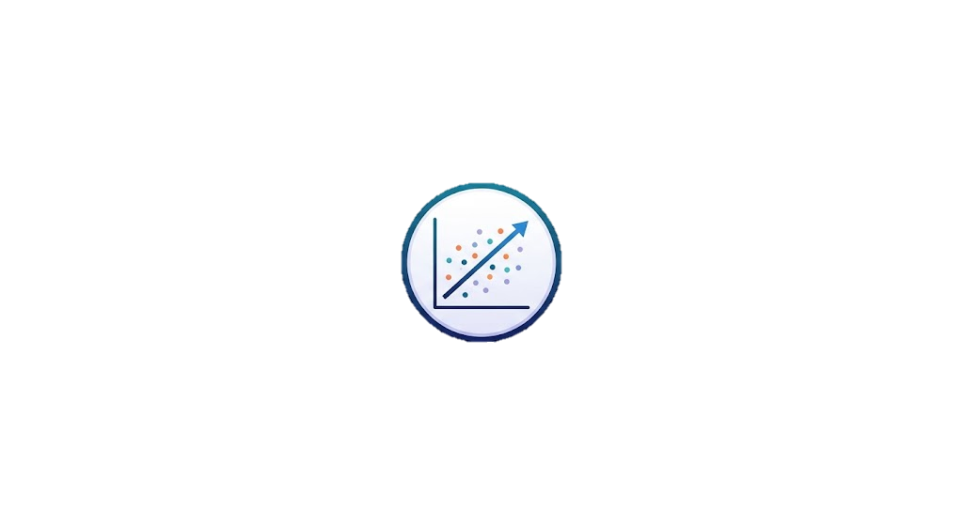 | Scatter Plots with Trendlines | The scattered dots show the distribution, while the "Trendline" proves the rule
 | Line & Area Charts | They clearly illustrate steep declines or climbs and are perfect for highlighting critical intersection points
 | Combo Chart (Columns + Lines) | We use this when we need to compare metrics that have completely different Combining them lets us tell the complete story of how these variables interact in one single view.
 | Radar / Spider Chart | It is brilliant for a "360-degree evaluation" of a single entity. It allows us to instantly visualize a student's unique footprint, immediately revealing if they are well-rounded, STEM-leaning, or Humanities-leaning.
 | Key Influencers (Advanced  Analytics) | Instead of manually guessing what causes poor performance, this visual uses machine learning to isolate and rank the absolute biggest drivers

2.Different relations showed in our dashboard

Relationship / Analysis Name | Required Columns | Insight / Objective | Relationship / Analysis Name
Academics & Demographics | Department vs Grade | Department, Grade | Compare final grades and success rates across  different educational stages.
 | Scores by Gender | Gender, Math_Score, Science_Score,  English_Score... | Check if males or females excel in specific subjects.
 | Age Impact in Same Department | Age, Department, Grade | Determine if older/younger students in the same grade perform differently.
 | Hardest and Easiest Subjects | All Scores columns, Department | Identify subjects needing extra support basedon average scores.
Socio-Economic | Parent Education vs Grade | Parent_Education_Level, Grade | Check if parents' educational background positively affects student grades.
 | Income vs Internet Access | Family_Income_Level,  Internet_Access_at_Home | Identify the digital divide and internet availability by income levels.
 | Internet Access vs LMS Usage | Internet_Access_at_Home,  lms_active_avg_hrs,  resource_access_avg_hrs | Does lack of internet prevent students from using the educational platform?
 | Income Level vs Grade | Family_Income_Level, Grade | Does higher income necessarily mean better grades?
Wellbeing & Habits | Study Hours vs Grade | Study_Hours_per_Week, Grade | Determine the optimal study hours for getting an "A" grade.
 | Sleep vs Stress | Sleep_Hours_per_Night,  Stress_Level (1-10) | Analyze mental health and how sleep reduces stress levels.
 | Stress vs Grades | Stress_Level (1-10), Grade | Do highly stressed students get  lower grades?
 | Extracurriculars vs Study Hours | Extracurricular_Activities,  Study_Hours_per_Week | Do activities take away from study time or help organize it?
 | Extracurriculars vs Stress | Extracurricular_Activities,  Stress_Level (1-10) | Does participating in activities  relieve psychological stress?

Relationship / Analysis Name | Required Columns | Insight / Objective | Relationship / Analysis Name
LMS Engagement | LMS Login Frequency vs Grade | lms_login_freq_per_day,  Grade | Does frequent platform login guarantee academic success?
 | Active Hours vs Scores | lms_active_avg_hrs,  Math_Score, Science_Score | Impact of actual active time spent on the system on scientific scores.
 | Resource Access vs Grade | resource_access_avg_hrs,  Grade | Does reading additional resources improve the final grade?
Attendance & Compliance | Academic Attendance vs Grade | academic_attendance, Grade | Impact of class attendance rate on final academic evaluation.
 | Non-Academic Attendance  vs Activities | non-academic_attendance,  Extracurricular_Activities | Student commitment to out-of-class events and its link to activities.
 | Late Assignments vs LMS Logins | assi_late, lms_login_freq_per_day | Is assignment delay caused by not logging into the platform?
 | Late Assignments vs Grade | assi_late, Grade | Is assignment delay always accompanied by academic decline?
 | Stress vs Late Assignments | Stress_Level (1-10), assi_late | Does high stress lead to procrastination and late assignments?
Subject Correlations | Math vs Science | Math_Score, Science_Score | Correlation between analytical and scientific skills.
 | Math vs Computer Science | Math_Score,  Computer_Science_Score | Measuring correlation between  mathematical logic and programming.
 | Language Skills | English_Score, French_Score | Is a student who excels in English also good at French?
 | Assignments vs Final Score | assi_Math, Math_Score (  Apply to all subjects) | Do continuous assignment scores reflect the actual final level of the student?
 | Math vs Science | Math_Score, Science_Score | Correlation between analytical and scientific skills.

Relationship / Analysis Name | Required Columns | Insight / Objective | Relationship / Analysis Name
Education Path | Engineering Track Indicator  (STEM / Math) | Math_Score  Computer_Science_Score | Identifies students who possess an analytical and logical mind and are qualified for STEM schools or the Math/Science track.
 | Science & Medicine Track Indicator | Science_Score  Math_Score | Discovers students passionate about natural phenomena and qualified for the Medical Science track.
 | Humanities Track Indicator  (Literary / Languages) | English_Score  French_Score  Social_Studies_Score | Highlights students excelling in ommunication skills, languages, and historical understanding to guide them to the Literary/Arts track.
 | Student Academic Footprint  (Individual Profile) | Student_ID or Name +  All Scores columns | Allows the academic advisor to select a specific student's name to view their complete skills map and identify their strongest subjects.
Improvement of Education and Technology | Measuring Platform (LMS)  Effectiveness as a Study Alternative | lms_active_avg_hrs  Study_Hours_per_Week  Average Grades | Is the electronic system effective to the extent that a student who uses it gets high grades even if their paper-based study hours are fewer?
 | Monitoring Procrastination & Early  Academic Risk | assi_late  lms_login_freq_per_day  academic_attendance | Early warning system: Detects students who stopped logging into the platform and started falling behind on submitting tasks before they fail.
 | The Role of School Activities in Character Building | Extracurricular_Activities  Stress_Level  Grade | Evaluating whether extracurricular activities are just a waste of time, or if they reduce stress and help raise the overall academic level.
 | Measuring Platform (LMS) Effectiveness as a  Study Alternative | lms_active_avg_hrs  Study_Hours_per_Week  Average Grades | Is the electronic system effective to the extent that a student who uses it gets high grades even if their paper-based study hours are fewer?

3- Our dashboard

3.1 Home page
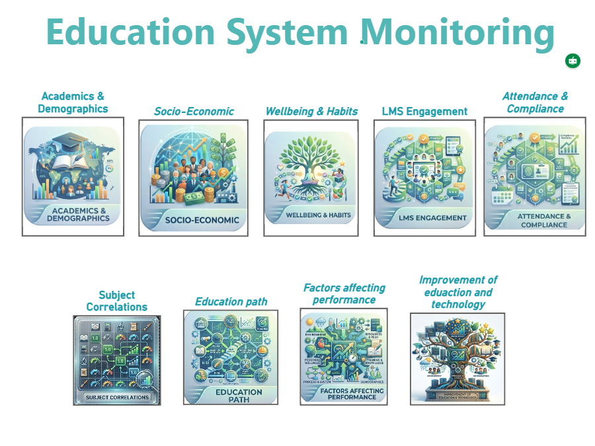

This dashboard serves as the foundational layer of the project, focusing on the demographic identity of the student body and linking it to initial academic standing to establish a baseline for further analysis.
- KPI Card (Total Student): Displays the total number of students enrolled in the system, which is 1,356.
  - Insight: This figure provides the primary reference point for all subsequent percentages and averages across the monitoring system.
- Gender Distribution (Top Left - Pie Chart): Breaks down the student population by gender.
  - Insight: The data shows a near-perfect balance in gender distribution, with males at 50.45% (1.24K) and females at 49.55% (1.21K).
- Departmental Breakdown (Bottom Left - Bar Chart): Illustrates the distribution of students across three educational levels.
  - Insight: Student counts are remarkably consistent across departments, with 6th Grade leading at 828 students, followed by 5th Grade at 822, and Middle School at 798.
- Subject Performance by Department (Top Right - Clustered Bar Chart): Compares average scores across various subjects (Math, Science, Languages, etc.) for each department.
  - Insight: Middle School stands out with the highest academic peak in Mathematics, averaging a score of 85, while other subjects across all grades remain relatively stable in the 70s range.
- Engagement & Extracurriculars (Bottom Right - Stacked Column Chart): Correlates student counts in each department with their participation in extracurricular activities.
  - Insight: There is a notable gap in engagement; the majority of students across all levels do not participate in extracurricular activities, with non-participants in Middle School reaching 491 compared to only 307 participants.
Data Modeling & Relationships
This screen represents the first level of the project's star schema, relying on the connection between descriptive dimensions and academic fact tables.
- The Foundation Dimensions: The analysis primarily utilizes the Dim_Student table (containing gender and unique IDs) and a departmental dimension to categorize educational levels.
- Fact Integration: Academic performance data is pulled from the Fact_Grades table, while participation metrics are derived from activity-related fact tables.
- Technical Purpose: To ensure the accuracy of the totals in the Pie and Bar charts, One-to-Many relationships are established from the dimensions to the fact tables. This design ensures that filtering by "Department" or "Gender" flows correctly without duplicating the unique Student_ID count, preventing calculation errors in the overall student metrics.

3.2 Academics & Demographics
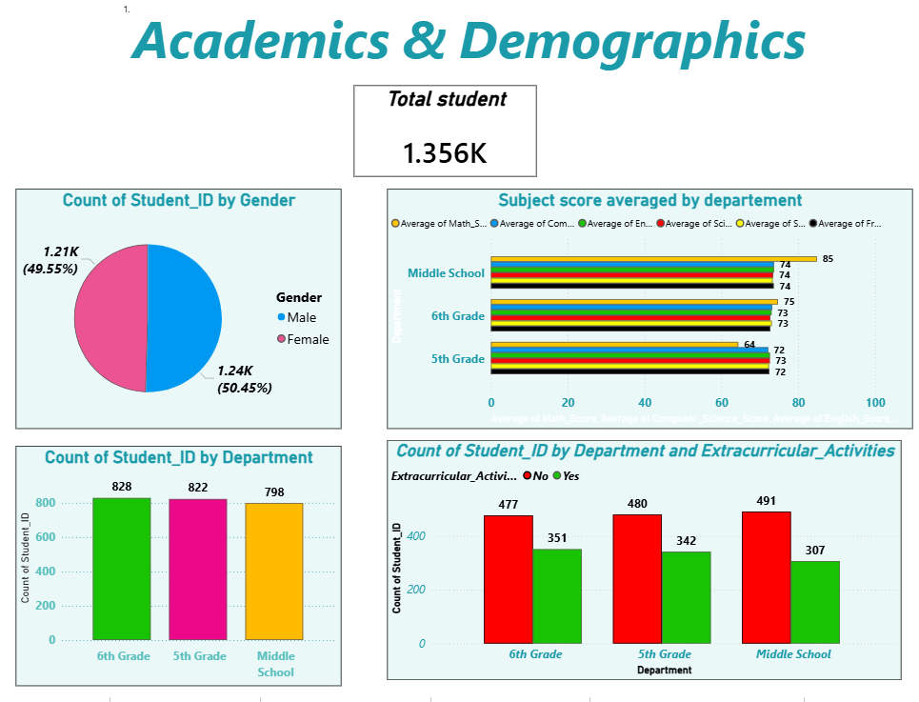

This dashboard serves as the foundational layer of the project, focusing on the demographic identity of the student body and linking it to initial academic standing to establish a baseline for further analysis.
- KPI Card (Total Student): Displays the total number of students enrolled in the system, which is 1,356.
  - Insight: This figure provides the primary reference point for all subsequent percentages and averages across the monitoring system.
- Gender Distribution (Top Left - Pie Chart): Breaks down the student population by gender.
  - Insight: The data shows a near-perfect balance in gender distribution, with males at 50.45% (1.24K) and females at 49.55% (1.21K).
- Departmental Breakdown (Bottom Left - Bar Chart): Illustrates the distribution of students across three educational levels.
  - Insight: Student counts are remarkably consistent across departments, with 6th Grade leading at 828 students, followed by 5th Grade at 822, and Middle School at 798.
- Subject Performance by Department (Top Right - Clustered Bar Chart): Compares average scores across various subjects (Math, Science, Languages, etc.) for each department.
  - Insight: Middle School stands out with the highest academic peak in Mathematics, averaging a score of 85, while other subjects across all grades remain relatively stable in the 70s range.
- Engagement & Extracurriculars (Bottom Right - Stacked Column Chart): Correlates student counts in each department with their participation in extracurricular activities.
  - Insight: There is a notable gap in engagement; the majority of students across all levels do not participate in extracurricular activities, with non-participants in Middle School reaching 491 compared to only 307 participants.

Data Modeling & Relationships
This screen represents the first level of the project's star schema, relying on the connection between descriptive dimensions and academic fact tables.
- The Foundation Dimensions: The analysis primarily utilizes the Dim_Student table (containing gender and unique IDs) and a departmental dimension to categorize educational levels.
- Fact Integration: Academic performance data is pulled from the Fact_Grades table, while participation metrics are derived from activity-related fact tables.
- Technical Purpose: To ensure the accuracy of the totals in the Pie and Bar charts, One-to-Many relationships are established from the dimensions to the fact tables. This design ensures that filtering by "Department" or "Gender" flows correctly without duplicating the unique Student_ID count, preventing calculation errors in the overall student metrics.

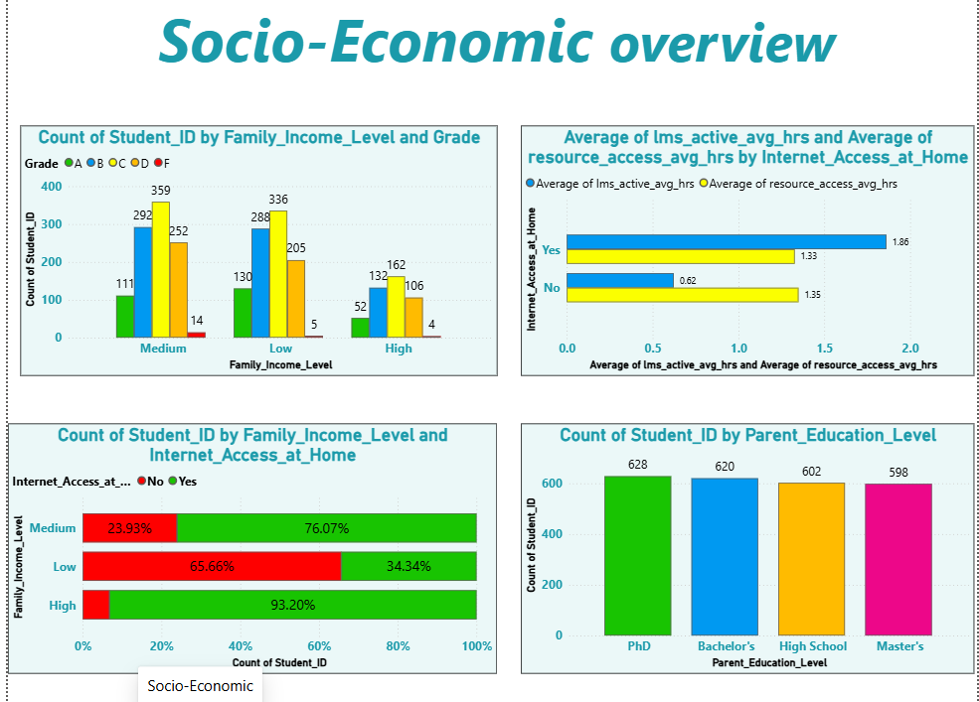
3.3 Socio-Economic overview

This dashboard focuses on external, off-campus factors that influence a student's educational journey. It consists of four main visualizations:
- Grades by Family Income (Top Left): A clustered column chart displaying how academic grades (A through F) are distributed across High, Medium, and Low family income levels. Insight: It helps identify if socio-economic status is a barrier to achieving top grades.
- Digital Engagement by Internet Access (Top Right): A clustered bar chart comparing the average hours spent active on the LMS versus accessing resources, split by whether the student has home internet. Insight: It highlights a significant "digital divide"—students without home internet spend drastically less time actively engaged on the LMS (0.62 hrs vs. 1.86 hrs), even though their resource access time remains surprisingly similar.
- Internet Access by Income Level (Bottom Left): A 100% stacked bar chart showing the percentage of internet availability based on family income. Insight: It proves a direct correlation between poverty and lack of digital access; over 65% of low-income students lack home internet, compared to only 6.8% of high-income students.
- Parent Education Level Distribution (Bottom Right): A column chart showing the count of students based on their parents' educational background. Insight: The dataset is remarkably evenly distributed across PhD, Master's, Bachelor's, and High School levels, ensuring balanced analysis across these demographics.

Data Modeling & Relationships
To build this page in Power BI, the underlying data model relies on the following structural relationships:
- The Core Dimension (Dim_Student_Demographics): A main table containing the Student_ID and all socio-economic attributes (Family_Income_Level, Internet_Access_at_Home, Parent_Education_Level).
- Relationship to Academics (Fact_Grades): A One-to-Many relationship connects the Demographics table to the Grades table via Student_ID.

  - Why we use it: To filter and cross-reference academic performance (Grades A-F) against non-academic factors (Income Level) to spot systemic inequalities.
- Relationship to System Usage (Fact_LMS_Activity): A One-to-Many relationship connects the Demographics table to the system logs via Student_ID to aggregate the lms_active_avg_hrs and resource_access_avg_hrs.
Why we use it: To quantify the exact educational impact of lacking physical resources (like home internet) on digital learning engagement

3.4 Wellbeing & Habits
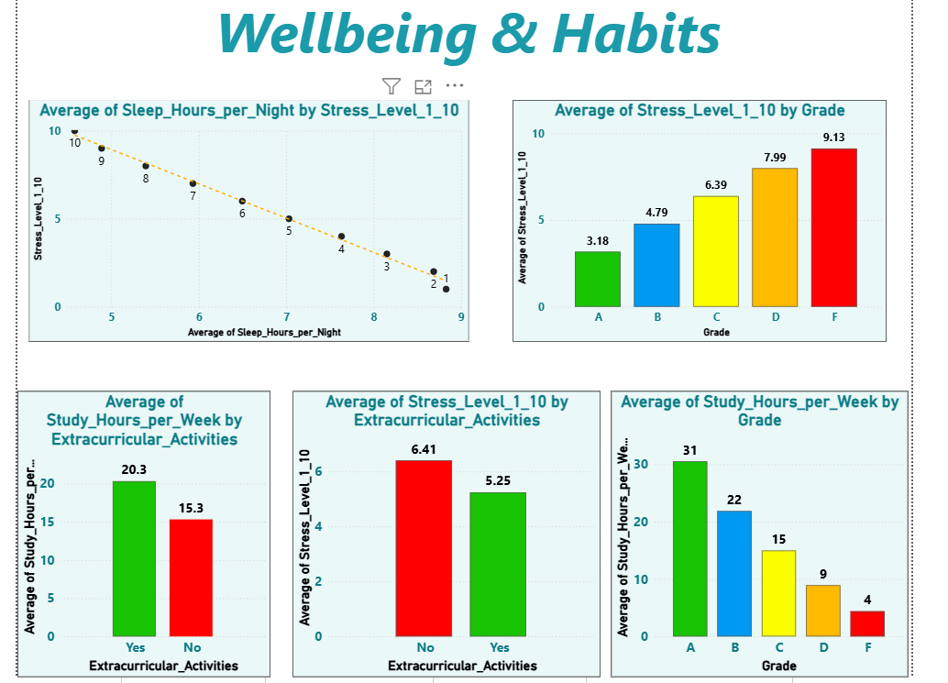

This dashboard focuses on students' personal habits, mental well-being, and their direct impact on academic performance. It features five key visualizations that deliver strong insights:
- Sleep vs. Stress (Top Left - Scatter/Line Chart): Illustrates the relationship between average sleep hours and stress levels (on a scale of 1-10).
  - Insight: Shows a near-perfect negative correlation. As sleep hours increase (up to 9 hours), stress levels drop to their lowest point (1), and vice versa.
- Stress by Academic Grade (Top Right - Column Chart): Compares average stress levels across different academic grades (A through F).
  - Insight: Students with the lowest grades (F) experience the highest levels of stress (9.13), while top-performing students (A) report the lowest stress levels (3.18).
- Study Hours by Extracurricular Activities (Bottom Left - Column Chart): Compares weekly study hours between students who participate in extracurriculars and those who do not.
  - Insight: A surprising and positive finding; students participating in activities actually study more hours (20.3 hours) compared to non-participants (15.3 hours), indicating superior time management skills.
- Stress by Extracurricular Activities (Bottom Middle - Column Chart): Compares stress levels based on activity participation.

  - Insight: Extracurricular activities serve as a stress reliever, with participating students reporting lower average stress (5.25) than their non-participating peers (6.41).
- Study Hours by Grade (Bottom Right - Column Chart): Displays the average weekly study hours required for each grade level.
  - Insight: A clear, direct positive correlation. Achieving a Grade A demands the highest study time (31 hours/week), steadily decreasing down to just 4 hours a week for Grade F students.

Data Modeling & Relationships
To construct this dashboard in the Power BI Model View, the underlying architecture relies on the following structure:
- Habits Table (Fact_Wellbeing_Habits): Contains the core numerical metrics (Sleep_Hours, Stress_Level, Study_Hours).
- Grades Table (Fact_Grades): Contains the academic evaluations (A, B, C, D, F).
- Student Dimension (Dim_Student): Contains the descriptive attributes, such as participation status (Extracurricular_Activities - Yes/No).
- Relationships: Both the Habits and Grades fact tables are connected to the central Student dimension table via One-to-Many relationships using the Student_ID as the primary key.
  - Technical Purpose: This schema allows for seamless cross-filtering, enabling the dashboard to slice psychological and habit-based metrics by academic performance or activity status.

3.5 LMS Engagement
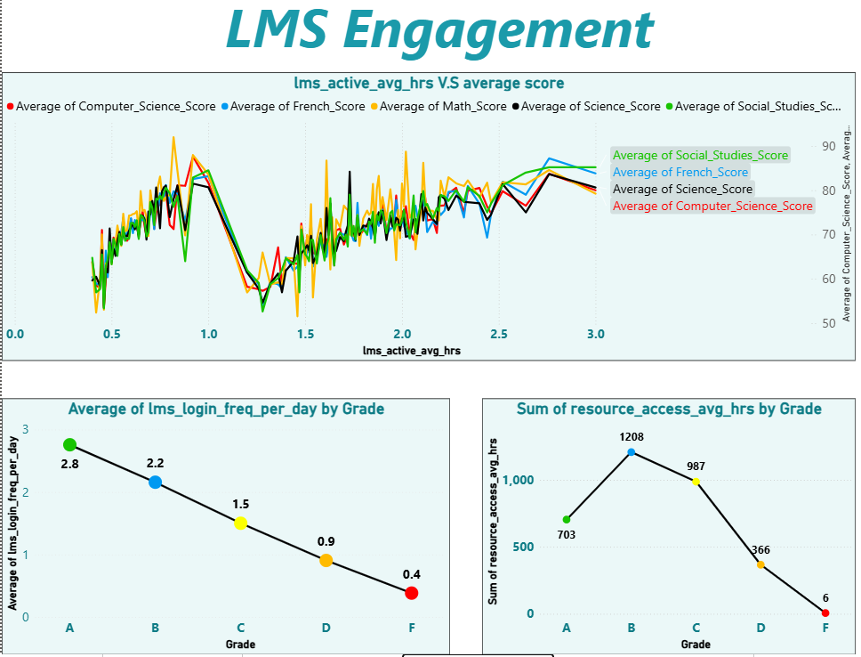
This dashboard tracks students' digital footprint within the Learning Management System (LMS) and correlates their online behavior with their academic outcomes. It features three crucial visualizations:
- Active Hours vs. Average Score (Top - Line Chart): Plots the average scores across five core subjects (Computer Science, French, Math, Science, Social Studies) against the average active hours spent on the LMS.
  - Insight: There is a broad positive correlation; as students spend more active time on the LMS (moving towards 2.5–3.0 hours), their average scores generally trend upward into the 80s across all subjects.
- Login Frequency by Grade (Bottom Left - Line Chart): Displays the average daily login frequency grouped by the final academic grade (A through F).
  - Insight: A perfect linear correlation. Top-performing "A" students are the most consistent, logging in an average of 2.8 times per day. Engagement drops steadily with performance, bottoming out at just 0.4 daily logins for "F" students. Consistent daily check-ins are a strong predictor of success.
- Resource Access by Grade (Bottom Right - Line Chart): Shows the sum of average hours spent accessing resources, categorized by grade.
  - Insight: A fascinating behavioral pattern emerges here. "B" and "C" students consume the vast majority of LMS resources (1,208 and 987 total hours, respectively). "A" students log fewer total resource access hours (703), suggesting higher learning efficiency or less need for remedial review. "F" students show almost zero engagement with system resources (6 hours).

Data Modeling & Relationships
To enable these insights in the Power BI Model View, the following architecture is required:
- LMS Fact Table (Fact_LMS_Activity): Contains the telemetry data from the learning platform, including lms_active_avg_hrs, lms_login_freq_per_day, and resource_access_avg_hrs.
- Academic Fact Table (Fact_Grades): Contains individual subject scores and the overall categorical Grade (A, B, C, D, F).
- Student Dimension (Dim_Student): The primary lookup table containing the unique Student_ID.
- Relationships: Both fact tables must be connected to Dim_Student via a One-to-Many relationship.
  - Technical Purpose: This star schema allows the categorical Grade column (from the Grades table) to slice and filter the behavioral metrics (like login frequency and resource access) stored in the LMS Activity tble without creating a many-to-many conflict.

3.6 Attendance & Compliance
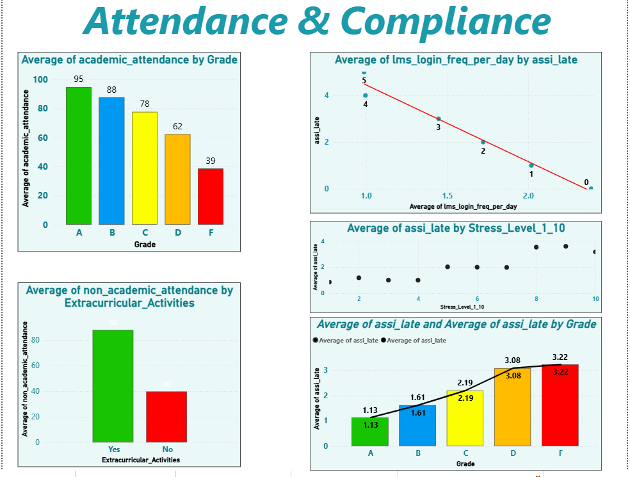

This dashboard examines the crucial relationship between student reliability (physical attendance and assignment compliance) and their overall success and well-being. It features five interconnected visualizations:
- Academic Attendance by Grade (Top Left - Column Chart): Displays the average academic attendance percentage across final grades.
  - Insight: There is a stark, direct correlation between physical presence and academic success. "A" students maintain a 95% attendance rate, while "F" students drop drastically to 39%. Skipping class is a primary indicator of academic failure.
- Non-Academic Attendance by Extracurriculars (Bottom Left - Column Chart): Compares non-academic attendance (e.g., school events, clubs) between students who do and do not participate in formal extracurricular activities.
  - Insight: Students involved in extracurriculars show significantly higher non-academic attendance (88 vs. 40). This indicates that extracurriculars foster a much stronger sense of community and school attachment.
- Login Frequency vs. Late Assignments (Top Right - Scatter/Line Chart): Plots the number of late assignments (assi_late) against average daily LMS logins.
  - Insight: A clear negative correlation. Students who log in frequently (2.0+ times a day) have near-zero late assignments. Lack of digital engagement directly translates to missed deadlines.
- Late Assignments by Stress Level (Middle Right - Scatter Chart): Maps the average number of late assignments against reported stress levels (1-10).
  - Insight: As the number of late assignments increases, so does the student's stress level (peaking at levels 8-10). This highlights that poor compliance and procrastination are major contributors to student anxiety.
- Late Assignments by Grade (Bottom Right - Combo Chart): Shows the average number of late assignments distributed by academic grade.
  - Insight: Compliance is a major differentiator in performance. Top-performing "A" students average very few late assignments (1.13), whereas failing "F" students average the highest (3.22).

Data Modeling & Relationships
To accurately reflect these metrics in the Power BI Model View, this page relies on bridging multiple fact tables through common dimensions:
- Compliance & Attendance Fact Tables: The model requires a Fact_Attendance table (storing academic and non-academic attendance percentages) and a Fact_Assignments table (storing the assi_late count).
- Integration with Previous Data: It also pulls from tables used in earlier dashboards: Fact_LMS_Activity (for login frequency) and Fact_Wellbeing_Habits (for stress levels).
- Relationships: All these disparate fact tables must be connected to the central Dim_Student table via One-to-Many relationships.
  - Technical Purpose: This architecture allows you to cross-filter compliance metrics (like late assignments) against psychological metrics (stress) and digital behavior (LMS logins) without creating ambiguous paths or circular dependencies in the data model.

3.7Subject Correlations
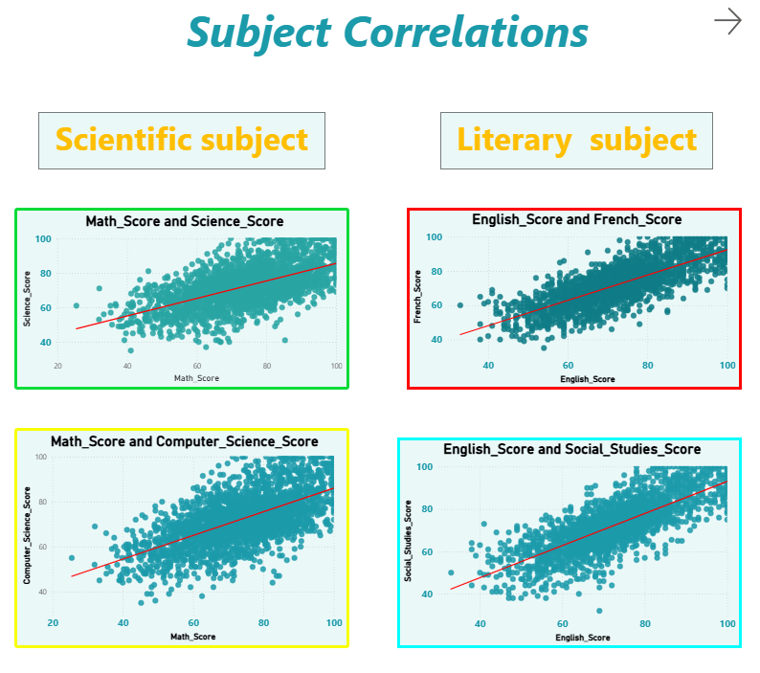
This dashboard is dedicated to predictive academic analysis, utilizing scatter plots with linear trend lines to identify clusters of student aptitude. The layout is strategically divided into two distinct academic pathways:
- Scientific Subjects (Left Column): Uses Math_Score as the baseline (X-axis) to evaluate performance in related STEM fields.
  - Math vs. Science (Top Left): Demonstrates a strong positive correlation. As math scores increase, science scores rise correspondingly.
  - Math vs. Computer Science (Bottom Left): Shows a similarly strong positive correlation.
  - Insight: Mathematical aptitude is a highly reliable predictor of overall success in scientific and technical disciplines. A student struggling in Math will likely need preemptive support in Science and Computer Science.
- Literary Subjects (Right Column): Uses English_Score as the baseline (X-axis) to evaluate performance in humanities and languages.
  - English vs. French (Top Right): Displays a clear positive correlation, indicating that strong linguistic skills in one language translate well to secondary language acquisition.
  - English vs. Social Studies (Bottom Right): Exhibits a strong positive trend, showing that the reading comprehension and analytical skills developed in English directly benefit performance in Social Studies.
  - Insight: Proficiency in a primary language (English) serves as a foundational skill that dictates success across the broader literary and humanities spectrum.

Data Modeling & Relationships
To generate these specific visual correlations in Power BI, the data model relies on the structure of the academic records:
- The Academic Fact Table (Fact_Grades): Unlike previous dashboards that required cross-filtering between different tables, this specific page primarily analyzes data within a single, "wide" fact table.
- Columnar Structure: The table must contain individual numerical columns for each subject (Math_Score, Science_Score, English_Score, etc.) rather than an unpivoted "Subject Name" and "Score" structure.
- Analytical Logic: The scatter plots plot two independent continuous numerical columns against each other. The trend line (regression line) is automatically calculated by Power BI's analytics pane based on the intersection of these two data points for every unique Student_ID.

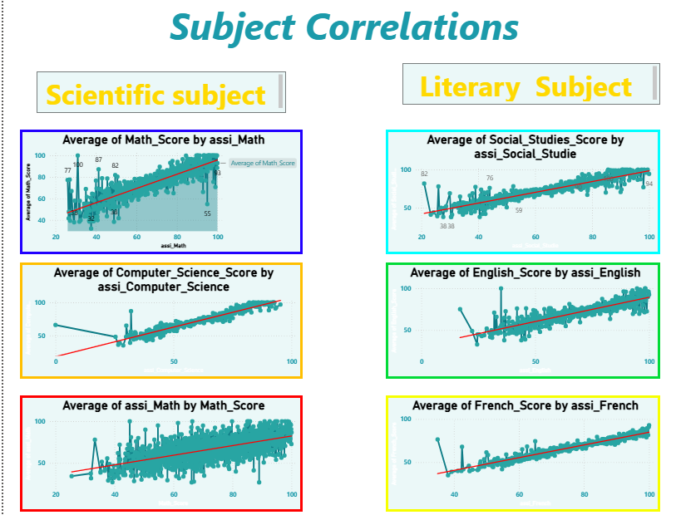
While the previous dashboard mapped different subjects against each other, this specific view investigates the internal consistency of grading within individual subjects. It correlates a student's continuous assessment scores (assignments) against their final subject score, categorized into Scientific and Literary tracks:
- Scientific Subjects (Left Column):
  - Math Score vs. Math Assignments (assi_Math): The top chart shows a highly concentrated positive trend. Students scoring near 100 on math assignments reliably score in the 80-100 range for their final grade. The bottom chart inversely plots assi_Math by Math_Score to confirm the bi-directional strength of this correlation.
  - Computer Science Score vs. CS Assignments (assi_Computer_Science): Displays an exceptionally tight linear regression. This indicates that computer science assignments are highly practical and perfectly reflective of the final assessment criteria.
- Literary Subjects (Right Column):
  - Social Studies, English, and French: All three charts plot the final subject score against its respective assignment score (assi_Social_Studie, assi_English, assi_French).
  - Insight: Across all literary disciplines, the trend lines show a clear, upward trajectory. Despite the subjective nature of humanities, consistent performance on coursework directly translates to high final marks.
Overall Insight: The data unequivocally validates the curriculum's assignment structure. Assignments are not merely "busy work"; they are highly accurate predictors of subject mastery.

Data Modeling & Relationships
To construct these predictive visual regressions in the Power BI Model View, the architecture relies on row-level granularity:
- The Academic Fact Table (Fact_Grades): This analysis relies on a "wide" table structure containing distinct numerical columns for both the coursework/assignment grades (e.g., assi_Math, assi_English) and the final holistic grades (e.g., Math_Score, English_Score).
- Visual Configuration: The visuals utilize Line/Area charts with an added Analytics Trend Line.
- Analytical Logic: Instead of relying on a relationship between two separate dimension tables, this logic plots two continuous metrics from the same fact table against each other for every Student_ID.
  - Technical Purpose: By plotting assignment aggregates on the X-axis and final scores on the Y-axis, Power BI's internal engine calculates the linear regression, proving the statistical validity of the grading rubric without requiring complex DAX measures.

3.8Education Path
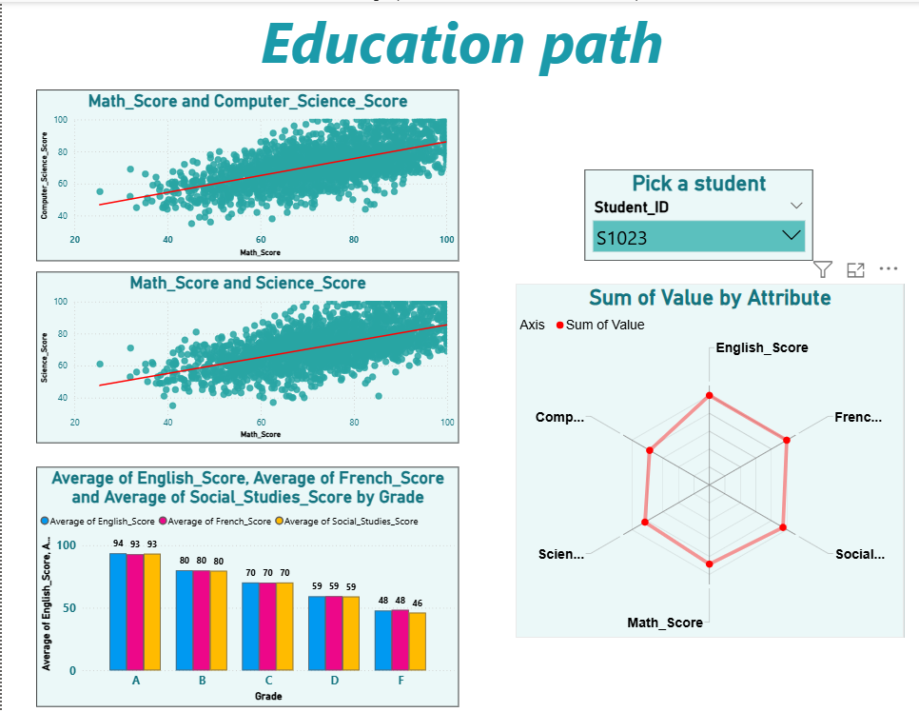

This dashboard transitions the analysis from broad, population-level trends to personalized student profiling. It is designed to act as an academic counseling tool to help determine a student's optimal future trajectory.
- Macro-Level Benchmarking (Left Column):
  - Scatter Plots (Math vs. CS / Math vs. Science): These visuals reiterate the established baseline that mathematical aptitude drives STEM success.
  - Literary Averages by Grade (Bottom Left): This clustered column chart establishes clear performance benchmarks for humanities subjects (English, French, Social Studies) across all grade tiers (A through F). It provides the "standard" against which an individual student can be measured.
- Micro-Level Student Profiling (Right Column):
  - Student Slicer: A dropdown filter allowing the user to isolate data for a specific individual (e.g., Student_ID: S1023).
  - Radar Chart / Spider Chart (Sum of Value by Attribute): This is the core of the dashboard. It maps the selected student's scores across all six disciplines simultaneously on a multi-axis web.
  - Insight: By selecting a student, educators can instantly visualize their unique "academic shape." A student leaning heavily toward STEM will skew the polygon towards Math/Science/CS, while a balanced student (like S1023) creates a large, symmetrical hexagon. This visual signature makes it immediately obvious which "Education Path" the student should pursue.

Data Modeling & Relationships
To function correctly, especially regarding the Radar Chart, this page requires specific data transformation steps in Power BI:
- The Unpivot Operation (Power Query): The title "Sum of Value by Attribute" strongly indicates that the underlying data for the radar chart was transformed. Standard "wide" fact tables (where each subject has its own column) do not work well with radar charts. The data in Fact_Grades had to be unpivoted in Power Query to create two new columns: an Attribute column (containing the subject names) and a Value column (containing the scores).
- Filtering Context: The Slicer utilizes the primary key (Student_ID) from the Dim_Student table.
- Relationships: A One-to-Many relationship connects Dim_Student to the unpivoted Fact_Grades table.
  - Technical Purpose: When a specific Student_ID is selected in the slicer, the filter context flows down the relationship, dynamically restricting the Radar Chart to only calculate the "Sum of Value" for that specific student's attributes, instantly morphing the shape to fit their profile.

3.9 Factors affecting performance
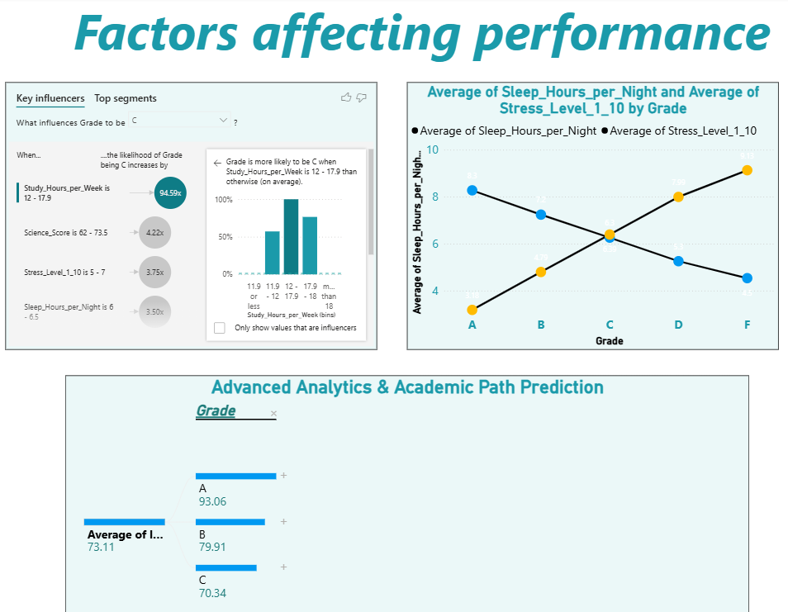

This dashboard moves beyond historical reporting into predictive and diagnostic analytics. It uses machine learning algorithms to identify exactly why students achieve certain grades.
- Key Influencers (Top Left - AI Visual): This visual runs statistical analysis to rank factors that drive a specific metric. In this screenshot, it analyzes what influences a student’s Grade to be exactly a C.
  - Insight: The algorithm identified that a student logging between 12 to 17.9 study hours per week is the absolute strongest predictor, increasing the likelihood of getting a "C" by a massive 94.59x. Secondary factors include specific ranges of Science scores, stress levels, and sleep hours. This removes human bias and mathematically proves what causes average performance.
- Sleep vs. Stress Intersection (Top Right - Dual Line Chart): Plots the average sleep hours and average stress levels against the final Grade (A through F).
  - Insight: This chart reveals a perfect "X" intersection. As grades drop from A to F, sleep drastically declines (8.3 to 4.5 hours) while stress drastically climbs (3.18 to 9.13). Crucially, the lines intersect exactly at Grade C (around 6.3 hours of sleep and 6.39 stress level). This visually defines the exact biological and psychological tipping point between a passing and failing trajectory.
- Decomposition Tree (Bottom - AI Visual): Titled "Advanced Analytics & Academic Path Prediction," this visual breaks down a high-level aggregate metric into its contributing dimensions.
  - Insight: It allows users to conduct root-cause analysis by drilling down into the data. Here, the overall system average (73.11) is dynamically split by the Grade dimension, showing the underlying averages for A (93.06), B (79.91), and C (70.34) students. Users can click the "+" icons to continuously split the data by other variables (like study hours or attendance) to see exactly how subgroups form.

Data Modeling & Relationships
To utilize Power BI's AI visuals (Key Influencers and Decomposition Tree) accurately without generating errors or circular dependencies, the underlying data model must be exceptionally clean:
- Unified Star Schema: The AI visuals require analyzing numerical facts (Sleep, Stress, Study Hours) and categorical dimensions (Grade) simultaneously. This means Fact_Wellbeing_Habits and Fact_Grades must be perfectly linked to the same central Dim_Student table using One-to-Many relationships.
- Bi-directional Filtering (Cross-filter direction): For the Key Influencers visual to evaluate how a dimension in one table (like Study_Hours in the Habits table) affects a dimension in another table (Grade in the Grades table), the relationships to the central dimension table might require Both (bi-directional) cross-filtering, or the data must be merged into a single flattened view/table within Power Query specifically for this AI analysis layer.
Data Binning: The Key Influencers visual automatically grouped continuous numerical data (like study hours) into "bins" (e.g., 12-17.9). This means the raw data is granular and continuous, allowing the AI engine to find the optimal ranges dynamically

3.10 Improvement of Education and Technology
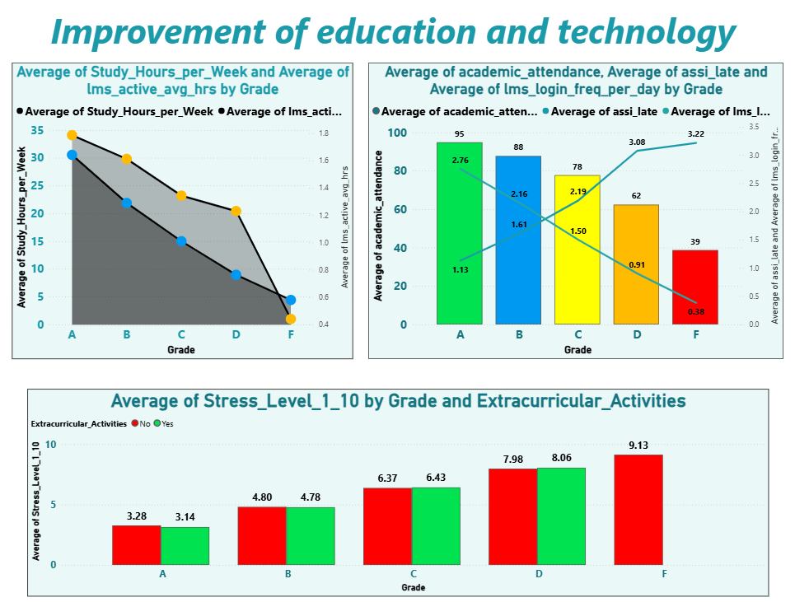

This final dashboard acts as the executive summary, synthesizing traditional academic effort, digital engagement, and psychological well-being to provide holistic recommendations for institutional improvement.
- Physical & Digital Effort Synergy (Top Left - Area Chart): Plots both traditional Study_Hours_per_Week and digital lms_active_avg_hrs against the final Grade.
  - Insight: The chart shows a perfectly synchronized decline. Top-tier students seamlessly integrate both analog study and digital LMS engagement. As performance drops toward an "F," both metrics collapse simultaneously. This proves that educational technology is not replacing traditional study; rather, successful students leverage both concurrently.
- The Triad of Compliance (Top Right - Combo Chart): A complex visual layering physical academic_attendance (columns) with digital lms_login_freq_per_day (descending line) and behavioral assi_late (ascending line), all grouped by Grade.
  - Insight: This clearly visualizes the anatomy of a failing student. As physical attendance drops (95 to 39) and digital presence fades (2.76 logins down to 0.38), non-compliance spikes (late assignments rise from 1.13 to 3.22). It confirms that absence in the classroom mirrors absence on the digital platform, both leading directly to missed work and poor grades.
- Stress, Grades, and Activities (Bottom - Clustered Column Chart): Compares average Stress_Level_1_10 across grades, split by participation in Extracurricular_Activities.
  - Insight: This chart debunks a common misconception. Stress levels are driven almost entirely by poor academic performance (rising from ~3.2 for "A" students to 9.13 for "F" students), not by extracurricular involvement. Within any given grade level (A, B, or C), the stress difference between participants and non-participants is statistically negligible. Notably, "F" students show zero participation in extracurriculars, suggesting isolation.

Data Modeling & Relationships
This capstone dashboard is the ultimate test of your Power BI Star Schema, as it pulls distinct metrics from completely different fact tables into single visualizations:
- The Ultimate Star Schema Validation: To build these visuals, the model successfully integrates data from Fact_Wellbeing_Habits (Study hours, Stress), Fact_LMS_Activity (Active hours, Logins), Fact_Attendance (Academic attendance), and Fact_Assignments (Late assignments).
- Centralized Slicing: All these disparate fact tables are successfully filtered by a single shared dimension—the Grade (likely residing in Fact_Grades acting as a dimension, or a centralized Dim_Student table).
- Technical Purpose: Utilizing a Combo Chart (Top Right) with multiple Y-axes requires pristine One-to-Many relationships from the central dimension to the various fact tables. If the model had Many-to-Many ambiguities or cross-filter direction errors, calculating independent averages for attendance, logins, and assignments on the same axis would result in Cartesian products or flat, incorrect numbers.


Chat bot

AI-Powered Educational Chatbot
The AI chatbot enables any stakeholder, regardless of BI expertise, to interrogate the educational dataset using natural language. It combines a Pandas analytical agent and a RAG document retrieval module into a unified hybrid system served via a Flask web application.

System Architecture
Component | Role
Data Layer | Silver Delta table loaded into Pandas Data Frame for real-time analytical processing
Lang Chain | Orchestrates all LLM interactions, prompt management, and both agent pipelines
SQL Agent | Translates natural language into SQL operations; handles all numerical/analytical queries
RAG Module | Semantic retrieval from vector store; handles all contextual and descriptive queries
Hybrid Router | Analyzes query intent; routes to Pandas Agent or RAG based on keyword + column detection
Flask Backend | API endpoint receives user messages, invokes pipeline, returns responses in real time
HTML/CSS Frontend | Asynchronous chat interface; displays responses without page reloads

2.Tools
Tool | Definition
Lang Chain | Lang Chain is a development framework that acts as the "glue" for  Generative AI applications, connecting Large Language Models with private data sources, managing conversation memory, and structuring chatbot workflows
Hugging Face | A framework that converts raw text into dense numerical vectors  (embeddings) representing meaning and context, allowing computers to recognize semantic relationships between differently spelled words.
ChromaDB | Purpose-built vector databases designed to store, index, and manage AI-generated embeddings, enabling ultra-fast semantic search based on conceptual meaning rather than exact word matches.
HTML + CSS | HTML + CSS + is the core technology stack used to build web interfaces, where HTML creates the structural backbone, CSS handles visual design and styling,
Flask (Python) | A lightweight, flexible web framework used to build backend servers, acting as a central coordinator that routes frontend requests to AI

2 RAG Pipeline
- Text Chunking: Educational documents segmented into smaller chunks for optimal retrieval granularity and contextual accuracy.
- Embedding: Hugging Face sentence-transformer models convert chunks into high-dimensional vector representations.
- Vector Store: Embeddings persisted in ChromaDB enabling sub-second semantic similarity search at inference time.
- Grounded Response: User query is embedded, compared to stored vectors, top-ranked chunks retrieved, and supplied to the LLM as context — reducing hallucination and improving factual accuracy.

3 Hybrid Routing Logic
Query contains: analytical keywords (average, count, total, percentage, compare, how many) AND at least one DataFrame column name (Math_Score, Grade, Family_Income_Level, lms_login_freq_per_day, etc.)
RAG route
All other queries: descriptive, explanatory, or conceptual questions not referencing structured dataset columns. This dual-pathway design ensures every query whether asking for a specific number or a contextual explanation is handled by the most appropriate engine, maximising both analytical precision and contextual accuracy.
Text Chunking
Educational documents segmented into smaller chunks for optimal retrieval granularity and contextual accuracy.
Embedding
Hugging Face sentence-transformer models convert chunks into high-dimensional vector representations.

Vector Store
Embeddings persisted in ChromaDB enabling sub-second semantic similarity search at inference time.
Grounded Response
User query is embedded, compared to stored vectors, top-ranked chunks retrieved, and supplied to the LLM as context reducing hallucination and improving factual accuracy.

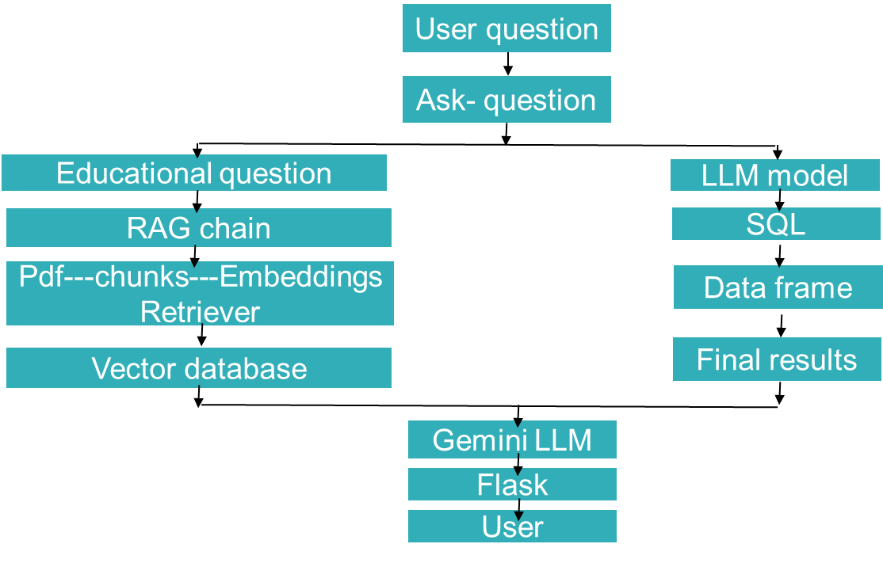
4. Key Analytical Findings
The six findings below represent the most strategically significant insights across all nine dashboard pages, combining quantitative precision with actionable business implications.
# | Finding
1 | Low-income students are 2.72× less likely to have home internet access, suppressing their LMS engagement by up to 3× — a structural barrier independent of academic motivation or effort.
2 | Grade A student’s study 7.75× more hours per week (31 vs. 4) and maintain 2.44× higher academic attendance (95% vs. 39%) than Grade F students.
3 | Extracurricular participation is positively correlated with both higher study hours (+5 hrs/week) and lower stress levels (−1.16 pts), directly disproving the widely-held distraction hypothesis.
4 | The Power BI Key Influencers AI visual identified that studying 12–17.9 hrs/week is a 94.59× multiplier for Grade C outcomes — providing a precise, data-backed threshold for academic support programs.
5 | Sleep deprivation and academic stress form a self-reinforcing cycle: less sleep → higher stress → more late submissions → worse grades → greater pressure → less sleep.
6 | Mathematical aptitude reliably predicts Science and Computer Science performance; English aptitude reliably predicts French and Social Studies — enabling data-backed educational pathway counseling.

5. Our Chatbot screenshot


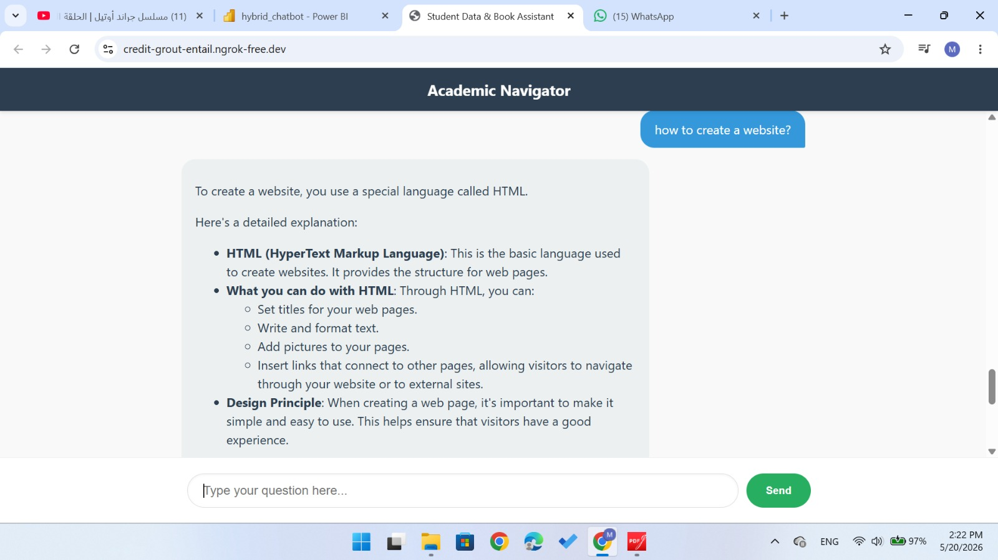
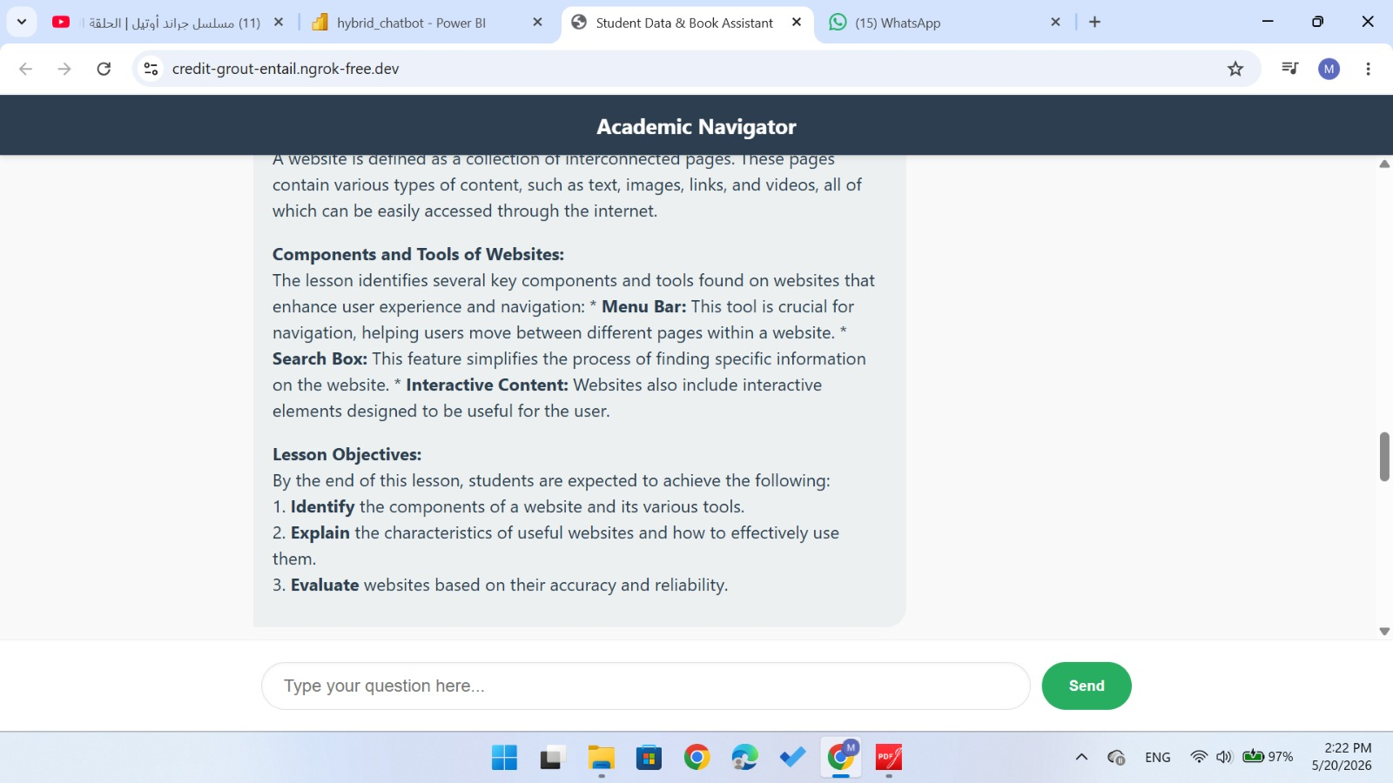
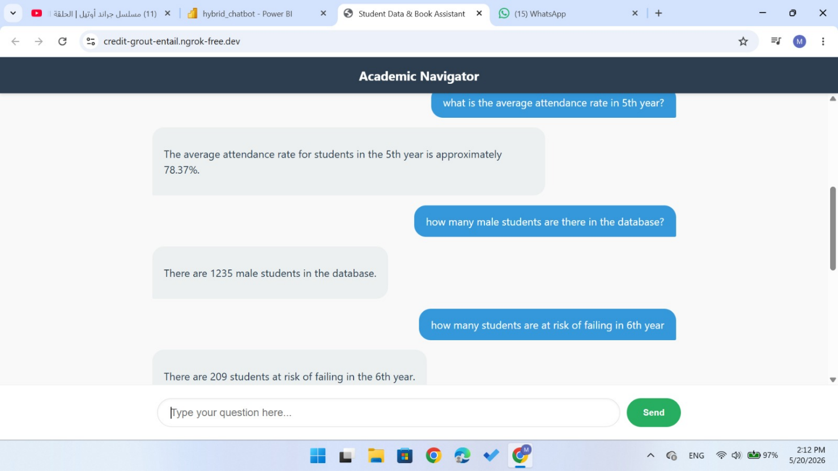

6.AI Chatbot Decisions
Q: Why did you use RAG instead of fine-tuning an LLM?
A: Fine-tuning would require substantial compute resources, a curated training dataset, and produces a model frozen at training time unable to incorporate new data without retraining. RAG retrieves relevant documents at inference time from a vector store that can be updated incrementally. This means the chatbot’s knowledge base can be extended with new cohort data, updated policies, or new research documents without any model retraining. For an educational system where data changes each semester, RAG is the architecturally correct and cost-efficient choice.
Q: What is the difference between the Pandas Agent and the RAG module? How does routing work?
A: The Pandas Agent handles structured, analytical queries questions requiring computation against the student DataFrame (averages, counts, comparisons, filtering). It translates natural language into executable SQL operations so the LLM can query structured

data without manually written code. The RAG module handles unstructured, contextual queries explanatory or descriptive questions where the answer comes from educational documents, not the dataset. The Hybrid Router distinguishes the two pathways by detecting analytical keywords (average, total, count) combined with DataFrame column names (Math_Score, Grade, Family_Income_Level) in the user query. Matches go to Pandas Agent; all others go to RAG. This dual-pathway architecture ensures every query is handled by the most appropriate engine.



Conclusion

The Data-Driven Education Monitor demonstrates the transformative potential of combining a robust data engineering pipeline with advanced business intelligence and conversational AI. By processing 1,356 student records through a three-tier Medallion Architecture on Microsoft Fabric, the project delivers a Star Schema data model powering nine specialized Power BI dashboards covering every dimension of student life — from academic scores and socio-economic background to digital engagement and psychological wellbeing.
The AI chatbot democratizes access to the data: stakeholders unfamiliar with BI tools can ask questions in plain English and receive precise, grounded answers through the Pandas agent or the RAG retrieval module. Together, these two layers — the BI dashboards and the chatbot — serve different stakeholder needs from the same underlying data platform.
Most critically, the project proves that student success cannot be optimized through any single intervention. Physical attendance, digital engagement, sleep quality, study habits, and socio-economic support are deeply interconnected variables that must be addressed as a unified system. The platform identifies at-risk students early, guides them toward appropriate educational pathways, and provides the data framework for evidence-based, unified intervention programs.

Final Positioning Statement
This project is an industry-style prototype demonstrating a complete, end-to-end data analytics platform from raw CSV ingestion through PySpark transformations, Delta Lake storage, Star Schema modeling, nine Power BI dashboards, and an AI-powered conversational chatbot. It reflects the architecture, engineering patterns, and technologies used in enterprise Modern Data Stack environments, designed and delivered entirely by the student team.
Core strengths demonstrated:
Data Engineering: Microsoft Fabric + Apache Spark + Delta Lake + Medallion Architecture Business Intelligence: Power BI + DAX + Star Schema + AI Visuals (Key Influencers, Decomposition Tree)
Applied AI: LangChain + RAG + Pandas Agent + Hybrid Routing + Flask API Business Thinking: Root-cause analysis + predictive modeling + actionable stakeholder insights

